02/11/2018

Irene Nizzoli, Isabella Piacentini, Elio Salvini

Politecnico di milano

RASD

RASD of Data4Help, AutomatedSOS and Track4Run

Sommario

1. Introduction 3

1.1 Purpose 3

1.1.1 Goals 3

1.2 Scope 4

1.2.1 Description of the given problem 4

1.2.2 World, shared and machine phenomena 4

1.3 Definitions, Acronyms, Abbreviations 5

1.3.1 Definitions 5

1.3.2 Acronyms 5

1.3.3 Abbreviations 5

1.4 Document Structure 5

2. Overall Description 7

2.1 Product perspective 7

2.2 Product Functions 9

2.2.1 Data Management 9

2.2.2 Request Management 9

2.2.3 Request in case of need 9

2.2.4 Track Runners 10

2.3 User Characteristics 10

2.4 Domain Assumptions 10

3. Specific Requirements 11

3.1 External Interface Requirements 11

3.1.2 Hardware interfaces 11

3.1.3 Software interfaces 11

3.1.4 Communication interfaces 11

3.2 Scenarios 12

3.2.1 Scenario 1 12

3.2.2 Scenario 2 12

3.2.3 Scenario 3 12

3.2.4 Scenario 4 12

3.2.5 Scenario 5 12

3.3 Functional Requirements 13

# 1. Introduction

## 1.1 Purpose

This is a Requirement Analysis and Specification Document (RASD) which purpose is to describe the goals, requirements and domain assumptions of the system. It will contain the non-functional limitations and general use cases to better describe the client’s needs and the typical usage of the application. This document will be used by the developers of the software during the implementation phase but also during analysis, testing and contractual discussions.

Data4Help general purpose is to give access of health status information to third parties either about groups or single individuals. The application should ensure tracked client’s privacy and anonymity and also allow third parties to subscribe to certain request and receive new data as soon as they are updated. In general, third parties, such as big companies, could use this system to gain a better general knowledge of possible clients’ needs and habits to improve their business. On the other hand, it could be used by individuals that have the desire to monitor the status of an elderly parent or a child, given the permission of the latter individuals.

AutomatedSOS will use the same data acquired by Data4Help with the goal of helping elderly people in need of immediate medical aid. The system will work by analysing the data obtained and checking the health parameters continuously. This should provide help for people in need way faster than they would have received without this system.

Track4Run will, as well as AutomatedSOS, use the features offered by Data4Help. The purpose in this case is to be able to track participants during a run. The system should also allow organizers to choose a path for the run and let spectators follow the athletes position on a map during the race.

### 1.1.1 Goals

1. Third parties can request access to data of some specific individuals
2. Third parties are allowed to request access to anonymized data of groups of individuals
3. Third parties can access the data of specific individuals
4. Third parties are able to access anonymized data of groups of individuals
5. Subscribed users are given the choice to accept or refuse third parties’ requests to access their data
6. To subscribed users is guaranteed anonymity
7. Subscribed costumers receive immediate help when they are displaying serious medical conditions
8. Spectators are able to know the position of the athletes on the path of the run

## 1.2 Scope

### 1.2.1 Description of the given problem

Data4Help is a service that acquires data from subscribed individuals, after asking for their consent, using devices such as smartwatches or similar. Third parties can also benefit from this service. After registration, they can formulate two types of request. The first one is to access the data of a single individual: for this request the application gives the user the freedom to accept or refuse the request. The second request is to access the data of a group of individuals, in this case it’s the application that gives the access to the data and must deny it if the number of individuals is below 1000 (the anonymity could not be guaranteed in this scenario). The application also gives third parties the possibility to subscribe to receive new data as soon as they are available.

TrackMe, through another service, called AutomatedSOS, gives the possibility to elder subscribers to receive immediate help in case of need. This application detects if the user’s parameters are below a certain threshold and immediately contacts a medical center to send an ambulance to the exact location of the subscriber.

Another application created by TrackMe is Track4Run. This service allows spectator to track participants in a run using their position on a map. This application allows organizers to create a path for the run and participants to register to the run.

### 1.2.2 World, shared and machine phenomena

* World phenomena:

1. Third parties monitor health status and location of individuals
2. Individuals agree to provide their data to TrackMe
3. Third parties access to data of individuals (who agreed to give them)
4. Third parties access to data of groups of anonymous individuals
5. Third parties recognize an individual by his/her CF or SSN
6. Organizers define the path of the run
7. Runners enroll to a run
8. Users see on a map the runners’ position

* Shared phenomena:

1. Registration of individuals
2. Registration of third parties
3. Users’ data acquisition through smartwatches or similar devices
4. Forwarding of a third party’s request of access to personal data to a specific user
5. Users accept or refuse the requests from third parties
6. Let the previously saved user’s data available to third parties (if the request of access is   
   approved)
7. AutomatedSOS acquires health status data of its users from Data4Help
8. AutomatedSOS sends an ambulance in the location of its users (if their health status values are

below a certain threshold)

* Machine phenomena:

1. Request to access to anonymous groups data are approved or disapproved by TrackMe’s systems on the base of certain conditions
2. AutomatedSOS analyses users acquired data
3. AutomatedSOS sends requests to external medical service for an ambulance when the data go below the threshold

## 1.3 Definitions, Acronyms, Abbreviations

### 1.3.1 Definitions

* **Individual**: user of the application whose health status is monitored.
* **Third party**: user of the application who requests health status data acquired from individuals.
* **Data Acquisition Device:** device that can provide data about the health status of an individual.
* **Individual Request**: request (advanced by a third party) to get access to a specific individual’s data about his/her health status. In this case the identity of the individual is shown to the third party.
* **Group Request**: request (advanced by a third party) to get access to health status data of anonymous group of individuals.
* **Runner**: *individual* who has subscribed himself to a run.
* **Organizer**: user of the application who organises a run by defining a path.
* **Spectator**: user who can see the position of runners through the application.
* **Path**: path of a run.

1.3.2 Acronyms

* RASD: Requirement Analysis and Specification Document
* API: Application Programming Interface
* GPS: Global Positioning System
* DAD: Data Acquisition Device

### 1.3.3 Abbreviations

* [Gn]: nth goal
* [Dn]: nth domain assumption
* [Rn]: nth functional requirement

## 1.4 Document Structure

1. **Introduction**: this part presents *purpose* and *scope* of the applications Data4Help, AutomatedSOS and Track4Run. The applications goals are listed and described. In this section there is also an analysis of world, shared and machine phenomena that concerns these applications.
2. **Overall description**: further details about shared phenomena and model domain are provided. Also, most important requirements and domain assumptions are defined. The aim of this part is to focus user needs and to give an overall description of the application’s model.
3. **Specific Requirements**: all aspects presented in the previous section are more deeply analysed in this part. All application requirements are listed and their link with goals and domain assumptions is stressed. Use cases are defined, and most important cases are analysed with the support of diagrams. Hardware and software interfaces are analysed. Constrains and limitations of the application are identified; necessary software attributes are enlightened.
4. **Formal Alloy analysis**: More relevant and critical parts of the model described in the previous sections are deeply analysed in this part with the use of Alloy.
5. **Effort spent**: this part lists for each member who worked at this document the number of hours dedicated to each section.
6. **References**: external resources used in the development of the current document.

# 2. Overall Description

## 2.1 Product perspective

Data4Help services, and their links with AutomatedSOS and Tarck4Run, are globally described in the class diagram in *figure 1*. This diagram shows the most important class of the applications from a requirement viewpoint.

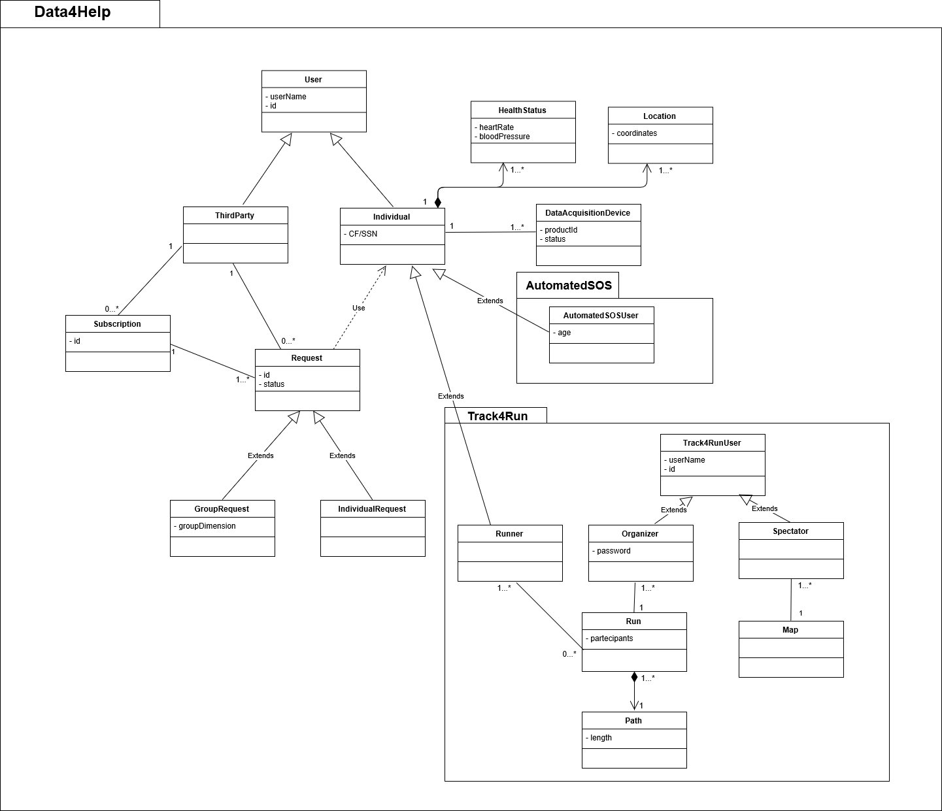  
*figure 1*

Data4Help divides its users in two categories, individuals (those whose health status is monitored) and third parties (those who request access to individual health status data). Also, requests are divided in two categories, group request and individual request. It is possible to create subscription for both types of requests.  
To subscribe to AutomatedSOS services it is necessary to subscribe also to Data4Help, indeed Data4Help users contains AutomatedSOS ones.

Track4Run users are split in three classes:

* Data4Help users:
  + *runners*, those who participate to a run;
* Track4Run users:
  + *organizers*, those who creates the path of a run;
  + *spectators*, anyone who want to see runners’ position.

Organizers and spectators are exclusively users of Track4Run, while runners are also users of Data4Help.

It is possible for each individual monitored by Data4help to register more than one DAD.   
Always for each individual it’s possible to keep track of his/her different health statuses and locations in time.

One of the more crucial aspects of Data4Help is the handle of requests of access to individual’s data, advanced by third parties. This process is shown in detail in the following diagram, *figure 2*.   
As we can see there are three main cases handled by the system, the single request (both groups and individuals), group subscriptions and individual subscription.

  
*figure 2*

## 2.2 Product Functions

Bearing in mind all the information about the three applications we can divide the most important functions of these systems in 4 groups: two for Data4Help, one for AutomatedSOS and one for Track4Run.

### 2.2.1 Data Management

This is an essential requirement. The users have to accept the request of the application to access their data. After that Data4Help is able to acquire individual’s data and keep a storage of them. In case of accepted request by third parties the application can give them access to the data they need.

Another great characteristic is that the application also let two external services (AutomatedSOS and Track4Run) use the acquired data of the individuals subscribed to those applications. Thanks to this property AutomatedSOS is capable of analyse the data of the users and Track4Run can access to the location of the runners.

### 2.2.2 Request Management

One of the main functions of the application is the way request from third parties are handled. The system needs to be able to diversify between individual request and group request and proceed accordingly. In the former case the application has to pass the request to the individual and wait for an eventual approval before giving access to the data. In the latter it is instead needed a phase of analysis of the request where the system checks if the number of people that reflect the parameters given by the third parties are over or below the threshold that guarantees anonymity to users. Only in the first situation the third parties receive access to the data which they asked for. Another feature is the management of subscriptions of third parties in regard of specific request: in this case, for example, the application needs to check if the limitation to guarantee privacy are still respected after every update of the users’ information.

### 2.2.3 Request in case of need

The principal function of AutomatedSOS is the ability to send an immediate request for help. First of all, the application needs to acquire the data of the subscribers thanks to Data4Help, then the service needs to constantly analyse them. If the data go below a certain threshold the service instantaneously has to contact an external medical facility providing it with the exact location of the user in need (the location is also acquired thanks to Data4Help).

### 2.2.4 Track Runners

The main requirement of Track4Run is the possibility to track the runners. The spectators, through a map, are able to locate the exact position of the athletes participating the run. The location of the runners is acquired thanks to the resources of Data4Help.

## 2.3 User Characteristics

In general, the actors of the application are these:

* Individuals: They represent all the people whose data are acquired by different sorts of tracking devices and stored inside the application. In case of AutomatedSOS these data are also continuously monitored to check if there is any need for medical assistance. As for Track4Run the individuals are the participants of the runs that are to be tracked by the application.
* Third Parties: Companies or single individuals that wish to know the data (health status/location) of other users.
* Organizers: In regard of Track4Run they are the people who choose the path for the run and they define it inside the application.
* Spectators: People who want to follow the position of the athletes during different runs inside the map provided by Track4Run.

## 2.4 Domain Assumptions

1. By registering the individuals agree that TrackMe acquires their data
2. Third parties know a way to identify the individuals whose data are of interest
3. When the number of individuals whose data satisfy a request is less than 1000, third parties are able to identify the individuals
4. Users have a unique identification code
5. Device sensors can provide an accurate enough current location
6. When the parameters go below a certain threshold the monitored individual’s health needs immediate medical help
7. Subscribed users don’t take the device sensor off
8. Subscribed users uses the device sensor correctly
9. Device sensors work correctly and without malfunctions
10. The external medical services are available 24/7 and work correctly
11. Participants have a tracking device on their person during the run
12. Organizers decide a path for the run
13. Participants enroll to the run

### 3. Specific Requirements

## 3.1 External Interface Requirements

### 3.1.2 Hardware interfaces

In order to provide a correct working of the application, devices that can monitor users’ health status (like smartwatches) are needed. Most of these devices need also a smartphone to have access to internet services and to communicate the monitored data. Devices used to monitor user’s status, or smartphones directly connected with them, must support GPS to provide Data4Help, AutomatedSOS and Track4Run services.

To gain access to individuals’ data, or to follow runners’ position during a run, it is possible to use any device able to provide access to web services.

### 3.1.3 Software interfaces

Services offered by AutomatedSOS and Track4Run needs the support of other external services. Interfacing with other software is essential if we think at the necessity of AutomatedSOS of contacting sanitary systems in case of emergency. While for Track4Run the use of an external software to show street, maps is an easy way to provide its service, avoiding the need of creating virtual maps of the interested areas.

**Sanitary emergency systems**: AutomatedSOS contacts the sanitary emergency systems if the monitored values of one of its users goes down a certain threshold. The application sends the coordinates of the user in danger and reports the emergency to the sanitary systems.

**Street maps services**: in order to give to the organizers, the possibility to define the path of the run, Track4Run needs a knowledge of the street map of the area designated for the event. Through the API of an external street maps service the application allows organizers to specify the path and to see its preview in the map. In addition, spectators of the run can see the street map of the area interested by the run, and the position of runners on the map; information required to recreate the map on spectator’s device are provided by the external street maps service.

### 3.1.4 Communication interfaces

Data4Help and Track4Run use a high-level protocol based on TCP to communicate with users’ devices (like HTTP for example). While AutomatedSOS exploits communication, protocols based on UDP; this choice is due to the need to be promptly in contacting the emergency systems if a user is in danger.

## 3.2 Scenarios

### 3.2.1 Scenario 1

Hannah is working full-time inside an important company and hasn’t got much time to go visit her elderly father Mike anymore. She still wishes to check on is conditions sometimes during the day, usually when he goes out to play chess with his friends in park near his house. His father is affected by dementia and could easily loose his way and end up not knowing where to go. She downloads Data4Help for herself and her father and sign him up to be monitored. Then she creates a request using Mike’s SSN and sends the requests in the right time slot. This way, if she sees on Data4Help that his father location indicates that he’s not going in the right direction she just calls him and helps him find his way to the park without any problems or accidents that may have occurred otherwise.

### 3.2.2 Scenario 2

Samsung is looking to understand the needs of a group of teenagers in an area of New York. It starts by creating a request inside Data4Help inserting these parameters. Data4Help checks if the number of people reflecting the boundaries are over 1000, which means that it is over the threshold to ensure privacy to the users. Seeing that the response is positive, Data4Help accepts Samsung request and sends the data of the group selected. Samsung decides to subscribe to the data to obtain a better understanding of the habits of the group and so it selects the possibility inside the application. Now every time the data are updated Samsung receives them, given that they still respect the anonymity limitations.

### 3.2.3 Scenario 3

Henry is 75, lives alone and he’s prone to hearth failures. Being worried for his health he subscribes to Data4Help and AutomatedSOS and starts wearing his new smartwatch 24/7. The device is linked to the application, which constantly monitors the data received. After a few months Henry isn’t feeling very well, but he collapses before he can call an emergency number. AutomatedSOS detects that his health status is not among normal values and contacts immediately the medical services. After a few minutes an ambulance arrives at Henry’s locations and he’s given the medical help he needs in time.

### 3.2.4 Scenario 4

Mark likes to go see runs very much but he’s very busy and sometimes his schedule overlaps with the races. He opens Track4Run and starts by searching for the right run to follow. Then, after selecting it he sees every athletes’ positions on the map. He wants to only see the position of his favourite runner, so he inserts inside the search bar the name of the athlete. Now he can see the positions and stats of the race all while comfortably completing his other errands.

### 3.2.5 Scenario 5

Sarah is organizing a new race in her town. She wants to give the possibility to people to follow the run in real-time. She opens Track4Run and starts to create a new race. The application asks her some information like the name of the run, the date, the city, the starting time and the maximum number of participants. At the end Track4Run allows her to add the precise path of the run. Days later during the race lots of spectators are able to follow the entire run she organized just by looking at an online map inside the application and without having to be near the path of the competition.

### 3.3 Functional Requirements

[G1]. Third parties can request access to data of some specific individuals

* + [D2] Third parties know a way to identify the individuals whose data are of interest
  + [D4] Users have a unique identification code
  + [R1] The service supports the registration of individuals
  + [R2] The service supports the registration of third parties
  + [R6] Third parties successfully register to the application

1. Third parties are allowed to request access to anonymized data of groups of individuals
   * [R2] The service supports the registration of third parties
   * [R6] Third parties successfully register to the application
2. Third parties can access the data of specific individuals
   * [D1] By registering the individuals agree that TrackMe acquires their data
   * [D5] Device sensors can provide an accurate enough current location
   * [D7] Subscribed users don’t take the device sensor off
   * [D8] Subscribed users uses the device sensor correctly
   * [D9] Device sensors work correctly and without malfunctions
   * [R1] The service supports the registration of individuals
   * [R3] Track me passes request of third parties to the specific individuals
   * [R4] Individuals accept the request from the third parties
3. Third parties are able to access anonymized data of groups of individuals
   * [D1] By registering the individuals agree that TrackMe acquires their data
   * [D5] Device sensors can provide an accurate enough current location
   * [D7] Subscribed users don’t take the device sensor off
   * [D8] Subscribed users uses the device sensor correctly
   * [D9] Device sensors work correctly and without malfunctions
   * [R5] TrackMe accept any request for which the number of individuals whose data satisfy the request is higher than 1000
4. Subscribed users are given the choice to accept or refuse third parties’ requests to access their data
   * [D1] By registering the individuals agree that TrackMe acquires their data
   * [D2] Third parties know a way to identify the individuals whose data are of interest
   * [D4] Users have a unique identification code
   * [R1] The service supports the registration of individuals
   * [R3] Track me passes request of third parties to the specific individuals
5. To subscribed users is guaranteed anonymity
   * [D3] When the number of individuals whose data satisfy a request is less than 1000, third parties are able to identify the individuals
   * [R5] TrackMe accept any request for which the number of individuals whose data satisfy the request is higher than 1000
6. Subscribed costumers receive immediate help when they are displaying serious medical conditions
   * [D11] Participants have a tracking device on their person during the run
   * [D12] Organizers decide a path for the run
   * [D13] Participants enroll to the run
   * [R10] Track4Run allows organizers to load path for the run
   * [R11] Track4Run allows participants to sign up inside the application as runners
   * [R12] Track4Run shows the position of the runners on the map
7. Spectators are able to know the position of the athletes on the path of the run
   * [D11] Participants have a tracking device on their person during the run
   * [D12] Organizers decide a path for the run
   * [D13] Participants enroll to the run
   * [R10] Track4Run allows organizers to load path for the run
   * [R11] Track4Run allows participants to sign up inside the application as runners
   * [R12] Track4Run shows the position of the runners on the map